VARSITY HONOUR

The News / Leicester Mercury
London Edition – Collaboration with the Daily Jang
July - August, 2003
Prof. Khurshid Ahmad



profkhurshidahmad.com all rights reserved

LEICESTER MERCURY

THURSDAY, JULY 17, 2003

Varsity honour


2 AUGUST 2003

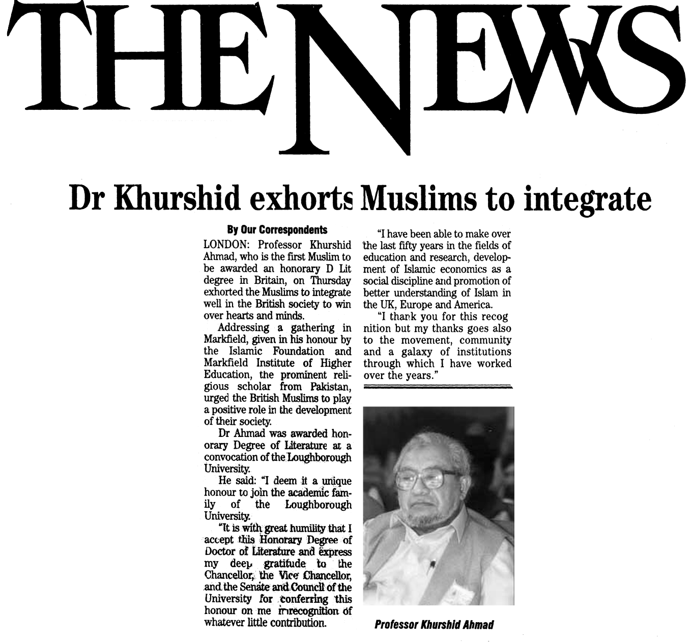

THE DAILY JANG LONDON

12 JULY 2003

