IQBAL AND THE MODERN RENAISSANCE OF ISLAM

IQBAL REVIEW
Karachi
1962
Prof. Khurshid Ahmad

IQBAL AND THE MODERN RENAISSANCE OF ISLAM
Prof. khurshid Ahmad
Iqbal was a versatile genius. The myriad aspects of his personality like the sparkling glow of a big diamond dazzle the eye. Some people I am enamored of the elegance of his style and the beauty of his art. Some others are impressed by the width of his knowledge and the depth I of his thought. Still others seek light from his philosophical vision and I political acumen. But, when a student of contemporary history looks at Iqbal he feels that although he was a great, poet, a noble master of his art, an inspired thinker, a sharp politician and an illustrious philosopher, he was something more than all that, he was a pioneer of the Renaissance of Islam in this country. And herein lies his real greatness.
The Muslim society had long been undergoing a spell of degeneration. The disintegration which set in after the early Caliphate continued to gradually sap the foundations of the Islamic civilization and after a long period of rout and rally, the dark night of gloom and stupor was cast over it. The creative faculties were benumbed and the political power was lost. Although different reform movements grew and many leaders of thought endeavored to awaken the Muslims from their slumber and infuse a new life in the Muslim society, little ice was actually broken. The most tragic part of it was that Islam no longer remained a dynamic politico-cultural force. It was reduced to the miserable and ineffective position of an amalgam of a few rites and rituals and was denied by-its own followers its real role of a culture producing factor. This was the unfortunate position when the British took hold of India. They very cleverly tried to impose the Western civilization upon the people of this region. This gave birth to plethora new problems.
The political and economic supremacy of the West and the system education which it imposed created a slavish mentality among the Muslims. They got engrossed in an inferiority complex. Even the last vestiges of their political confidence were destroyed. They were reduced to a very hectic existence.
Sings of a new awakening appeared on the horizon when comrade, al-Hilal and Zamindar shook the Muslims from their stupor and stirred them to rise and -do their duty. Khilafat Movement proved a great boon. It spurred the emotions of the Muslim India and encouraged it to enter the arena of political fight and cultural revolt. But the new awakening lacked in proper intellectual and philosophical foundations. It was Iqbal who laid these foundations. He was the true pioneer of the modem renaissance of Islam in India.
Iqbal's Diagnosis
Iqbal had a keen, vision and a penetrating mind. He studied the conditions of the Muslim society and fully realized the ills that infested its body. He clearly understood the real impact of the Western culture and read the writing on the wall. He knew that a revolutionary change in the outlook of the Muslims was the greatest need of the hour. He warned them that if they ignored the great challenge of their time they will be" eliminated from the surface of existence and be relegated to the dustbin of history.
Iqbal's diagonals of the problem were that the long period of cultural disintegration and the influence of the modem West had destroyed the moorings of the Muslim society. Muslims declined because they left Islam and because they adopted an easy life of submissiveness and inactivity. Under the spell of the West, their confidence in their values was shaken and they began to ape the Western ways of life. Moreover, an inferiority complex developed, in them and an estrangement between social life and the religious values ensued. The influence of non Islamic Sufism further sapped the springs of activity and Muslims became what they were.
This was realistic appraisal of the situation and, Iqbal harnessed all his energies to pull the Muslims out of this mire of degeneration.
New Attitude towards the West
First of all, Iqbal asked the Muslims to revise their attitude towards the West. He said that all was not good in Europe. He critically studied the fundamentals of the Western civilization and exposed their fallacies, He criticized those who blindly followed the West and asked them to use, reason and vision. In his Lectures he said:
"The only course open to us is to approach modem knowledge with a respectful but INDEPENDENT attitude".
He further expressed the fear "that the dazzling exterior of the European culture may arrest our movement". He took the lid off the destructive potentialities of the Materialistic civilization of the West and warned against the dangers of atheism and Godlessness. How beautifully he says in "Pas Cheh Bayad Kard Ai Aqwam-i-Sharq":
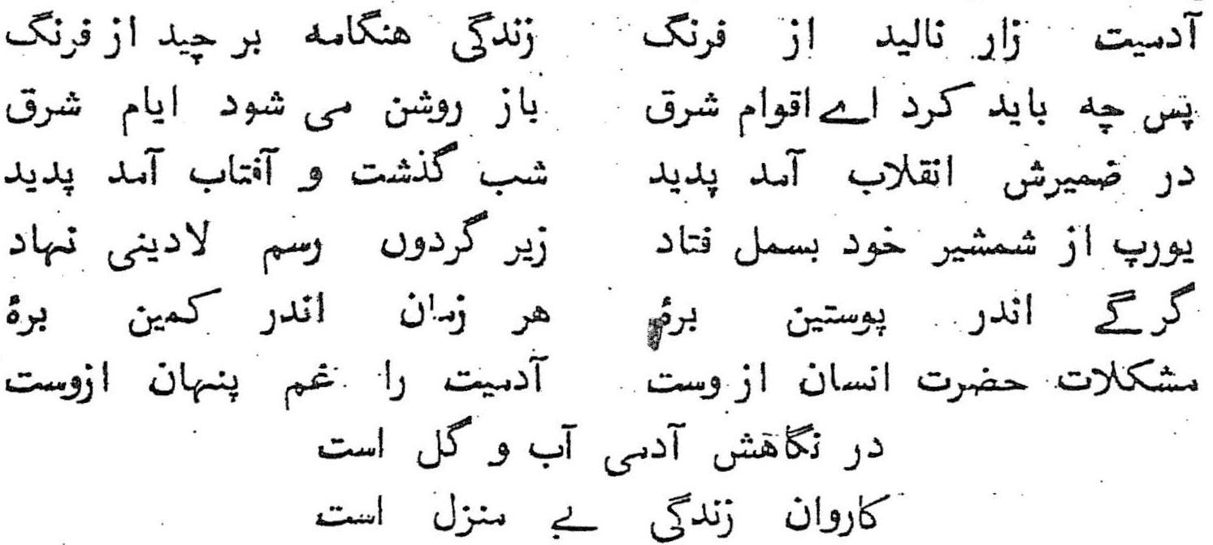
"Humanity is in agony at the hands of Europe
And life has lost its joyful tumult
What, then, is to be done, O peoples of the East,
That the lost glories of the Orient be regained?
A revolution has taken place in the depths of her being.
The night is passed and the sun has risen;
Europe lies smitten by its own sword
And has given irreligion to the World;
A wolf in lamb's skin,
Ever in ambush for the lamb,
It has brought trouble to humanity
And a growing grief,
Man in its eyes is but water and clay;
And life but a random caravan without a destination".
Iqbal gracefully declared that religion alone could extricate mankind out of the present Babel of social chaos and intellectual confusion. He said:
"And religion alone can ethically prepare the modem man" for the burden of the great responsibility which the advancement of modem science necessarily involves and restore to him that attitude of faith which makes him capable of winning a personality here and retaining it hereafter. It is only by rising to a fresh vision of his origin and future, his whince and whither, that man will eventually triumph over a society motivated by an in- human competition, and a civilization which has lost its Iqbal and the Modem Renaissance of Islam spiritual unity by its inner conflict of religious and political values".
While pointing out the major weaknesses of the West and the hollowness of its materialism and secularism he did not look right of those real factors which have been responsible for Europe's success and grandeur. He says:
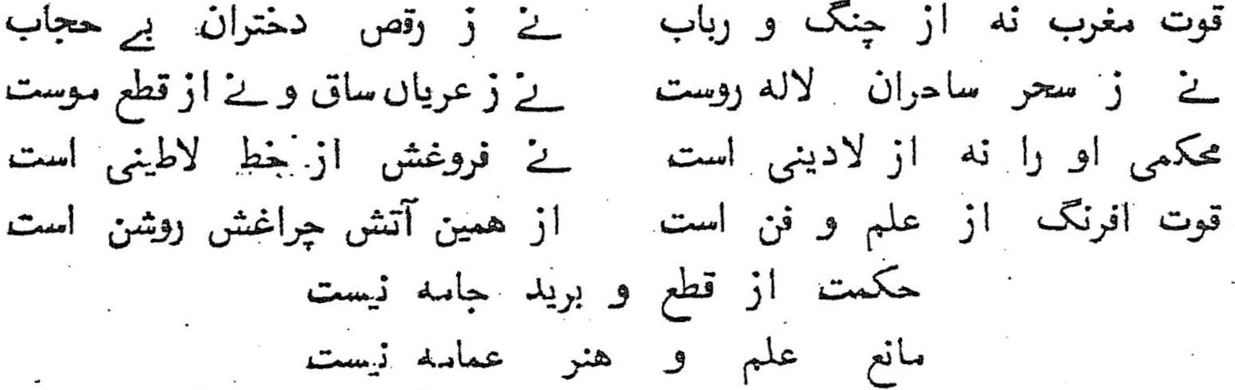
"The Secret of the West's strength is not in the lute and guitar,
Nor in the promiscuous dancing of her daughters,
Nor in the charms of her bright-faced beauties,
Nor in bare shins, nor in bobbed hair,
Her strength is not from irreligiousness
Nor is her rise due to Latin script,
The strength of the West is due to knowledge and science,
Her lamp is a light from this j5re only.
Knowledge does not depend on the style of your garments,
And a turban is no obstacle to the acquisition of knowledge."
Thus Iqbal surveyed the contemporary ideological panorama and honestly, presented the true achievements and the real failings of the Western civilization so that the blind imitation of it 'may be stopped. But he did not stop there. On the other hand he conclusively showed the indebtedness of the West to Islam in those things which led to its rise and growth and thus inspired in the Muslims a new confidence in their own values. He said:
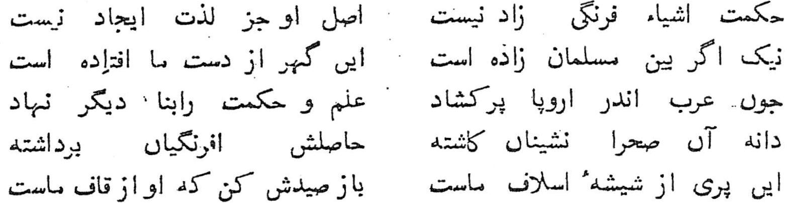
"Science was not brought into being by the West;
In essence it is nothing but the delight that lies in creation;
If you ponder well, it is the Muslims who gave it life;
It is a pearl we dropped from our hands.
When the Arabs spread over Europe,
They laid new foundations of learning and science.
The seed was sown by these dwellers of the desert;
But the harvest was reaped by the West.
This spirit is from the flask of our own ancestors;
Bring this fairy back, for she hails from our own Caucasus,"
Revolutionizing Thought and Action
Iqbal realized the need and the importance of the reconstruction of the Islamic thought. He knew that the modem attack on religion could be fought only with new weapons. The opponent will have to be met on his own ground. He also felt that Islam is a dynamic and revotionary movement but centuries of stagnation had laid some layers of dust over its religious thought. He stepped ahead to remove the dust and bathe the diamond clean so that it may again radiate light to the world groping about in the dark.
His lectures on ‘Reconstruction of Religious Thought in Islam’ are an attempt to fulfill this need. One may disagree with some of his interpretations but it is impossible to honestly deny the revolutionary message these lectures contain and the tremendous influence they left on the mind of Muslim India.
But Iqbal had a still higher mission in view. He was not a mere philosopher who could feel satisfied with the simple intellectual exposition of the ideology of Islam. He wanted to stir every fibre of a nation that had fallen in slumber and to arouse it to play its rightful role in the fashioning of the future. In his two masnavies, 'Asrar-e-Khudi’ and Rumuz-e-Baikhudi, he delineated the factors of individual and social growth. Iqbal discussed the causes of millat’s decline and threw light on the alien influences which disrupted its body-politic. Iqbal asked the Muslims to return to the real message of Allah and his Prophet.
The fundamentals of Islam, he said, were Tawheed, Risalat, Akhirat and Jihad. Tawheed provides for all members of the society a basis for unity of thought and unity of action. It is the greatest revolutionary force under the sun.
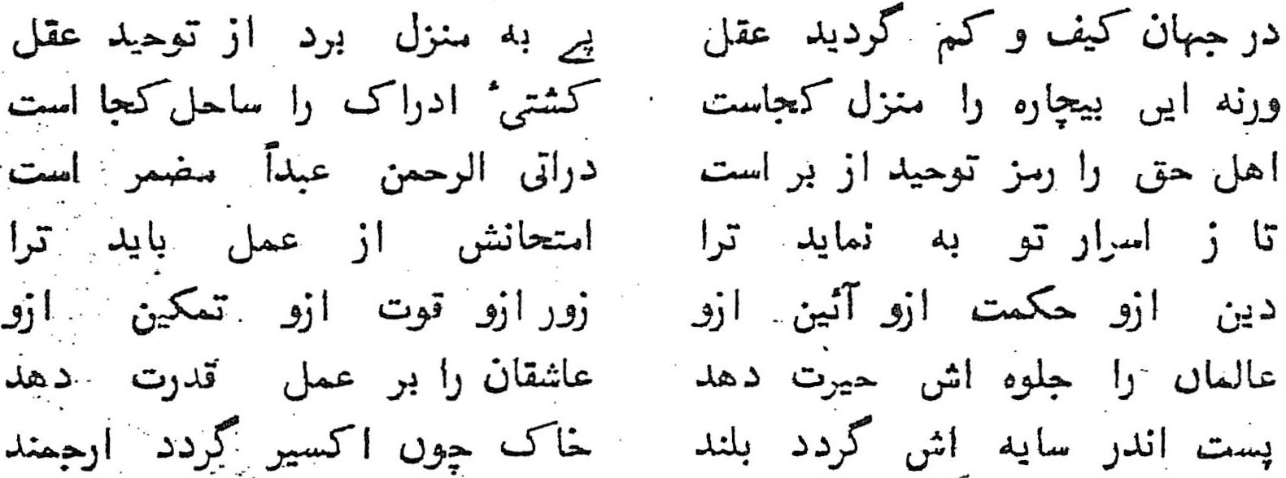
The Mind, astray in this determinate world
First found the path way to its distant goal.
By faith in Tawheed (Unity of God); what other home should,
Bring the helpless wanderer to rest?
Upon what other shore should Reason's barque
Touch however? All men intimate with truth
The secret of Tawheed have by heart,
Which is implicit in the sacred worlds?
He comes into the Merciful, a slave.
In action let faith's potency be tried,
That it may guide thee to thy secret powers:
From it derive religious wisdom, law.
Unfailing vigor, power, authority
Its splendor doth amaze the learned mind.
But giveth unto lover's force to act;
The lowly in its shadow reacheth high,
And worthless scum becomes like alchemy.
He dwelt upon the basic concepts of Islam in detail and showed the potentialities of the faith. His words gave a new message of life to a nation "forgotten so long, neglected so long".
Iqbal's poetry and thought stirred the Muslim India and inspired it to rise to the occasion and play its rightful role in the remaking of the world. After animating the nation with a new spirit, he also gave it a new concrete ideal to achieve in the political field so that the new energies that were released could be harnessed to build a homeland for Islam. This ideal was PAKISTAN.
Iqbal labored hard to strengthen and foster the belief that Muslims are a nation, an ideological community and that it is a dictate of their faith to establish a state, a society and a culture in the light of the principles given by the Quran and the Sunnah. He gave sober thought to the political problem of the Muslim India and after years of reflection suggested the idea of Pakistan in his Presidential Address to the Annual Session of All India Muslim "League in 1930 wherein he Said, "The life of Islam as a Cultural force in this country very largely depends on its centralization in a specified territory. This centralization of the most living portion of the Muslims of India will eventually solve the problem of India as well as of Asia. "This was essential so that the Muslim India may become "entitled to full and free development on the Lines of its own culture and tradition." And in a letter to the Quaid-e- Azam he wrote in 1937, a year before his demise:
"A separate federation of Muslim provinces reformed on the lines I have suggested above is the only course by which we can secure a peaceful India and save Muslims from the domination of non-Muslims. Why should not the Muslims of North West India and Bengal be considered as nations entitled to self-determination just as other nation’s m India and outside India are."
This was a pointer to the future. Nation followed the lead given by Iqbal and after great effort and sacrifice; Pakistan became a reality and inaugurated the new era of Muslim renaissance.
Iqbal's message was a message of action. He was a pioneer of Islamic Renaissance in this sub-continent and herein lies his real significance. We have very briefly outlined the great and gigantic task he performed. But we could present only a few glimpses of his work, for you cannot bottle sunshine. Let us end this study with those immortal words of this great revolutionary which moved a nation and worked as a clarion call:
"Vision without power does bring moral elevation but cannot give a lasting culture. Power without vision tends to become destructive and inhuman. Both must combine for the spiritual expansion of humanity."
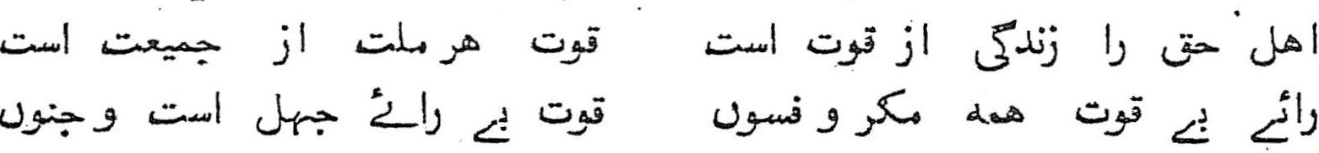
"The standard-bearers of truth live by being strong;
The strength of every nation lies in unity;
Wisdom without worldly power is but a fraud and a myth;
And worldly power without wisdom is folly and madness.”

